Figure 02: Home prepared plants

Figure 01: Preparing the soil

Figure 04: Equipment received from department

Figure 03: Donations of 20 Kumbuk plants

Figure 06: Starting the plantation

Figure 05: Categorizing the plants

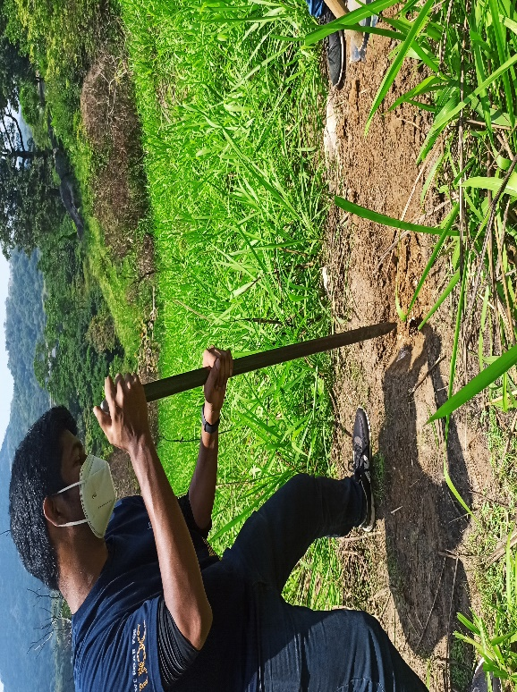

Figure 07: Preparing the land

Figure 08: Carrying the plants to the site

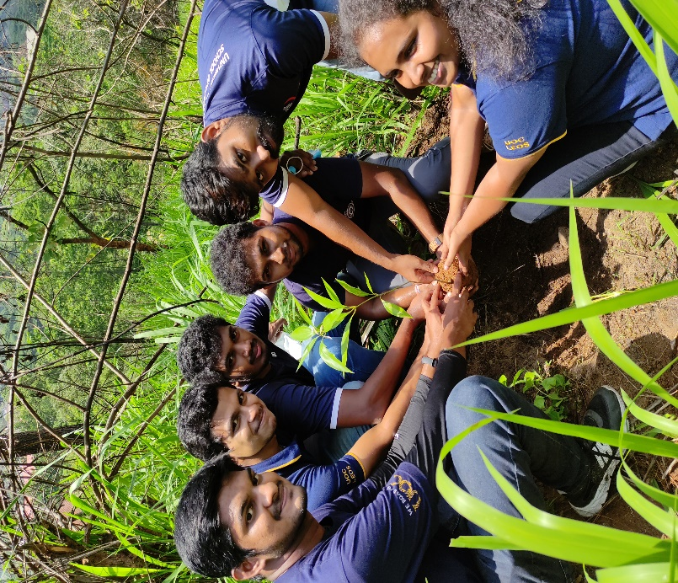

Figure 10: Carried plants the site

Figure 09: Carrying plants to the site

Figure 12: After planting

Figure 11:Colloborative work: Collaborative work

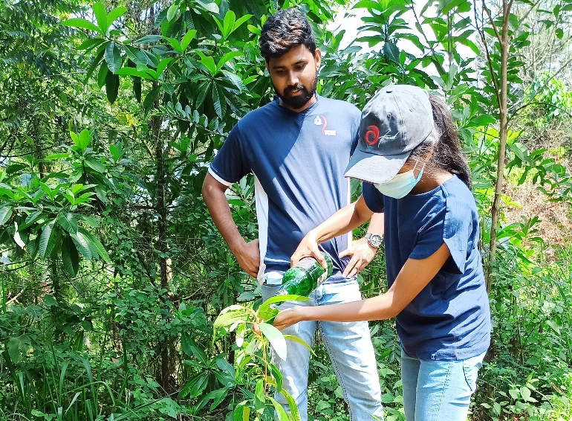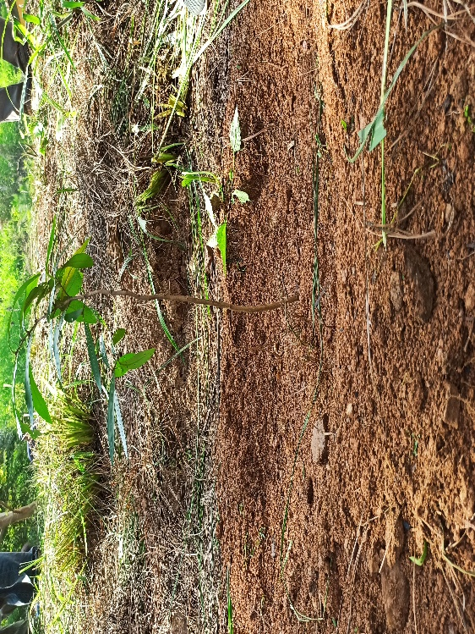

Figure 14:Watering a plant: Collaborative work

Figure 13:After planting: Collaborative work

Figure 16:Delivering the vote of thanks: Collaborative work

Figure 15:Group photo with the sponsors: Collaborative work

Figure 18:Group photo : Collaborative work

Figure 17:Delivering special thanks for the club Leos: Collaborative work